LOGIČNA POŠAST

VAJE ZA TEKMOVANJE

9. RAZRED

KVANTIFIKATORJI 2

mathema3.jpg

Naloga:

Določi pravilnost spodnjih stavkov.

C:\Users\mathema\AppData\Local\Microsoft\Windows\Temporary Internet Files\Content.Word\1-4c.wmfC:\Users\mathema\AppData\Local\Microsoft\Windows\Temporary Internet Files\Content.Word\1-4b.wmf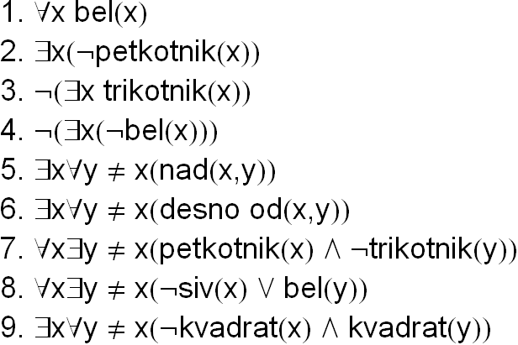

Rešitev:

C:\Users\mathema\AppData\Local\Microsoft\Windows\Temporary Internet Files\Content.Word\1-4d.wmf

Oznaki

R - pravilno

N - nepravilno

Primer 6. z besedo:

Obstaja tak x, da za vsak y različen od x velja: x je desno od y.

C:\Users\mathema\AppData\Local\Microsoft\Windows\Temporary Internet Files\Content.Word\2-4c.wmfC:\Users\mathema\AppData\Local\Microsoft\Windows\Temporary Internet Files\Content.Word\2-4b.wmf

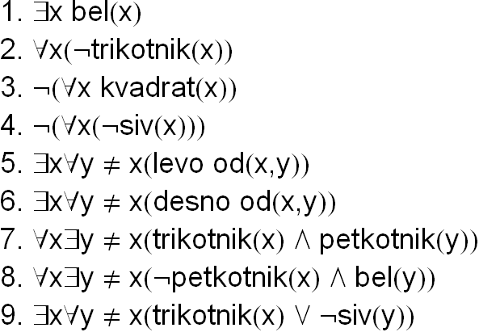C:\Users\mathema\AppData\Local\Microsoft\Windows\Temporary Internet Files\Content.Word\2-4d.wmf

C:\Users\mathema\AppData\Local\Microsoft\Windows\Temporary Internet Files\Content.Word\3-4c.wmfC:\Users\mathema\AppData\Local\Microsoft\Windows\Temporary Internet Files\Content.Word\3-4b.wmf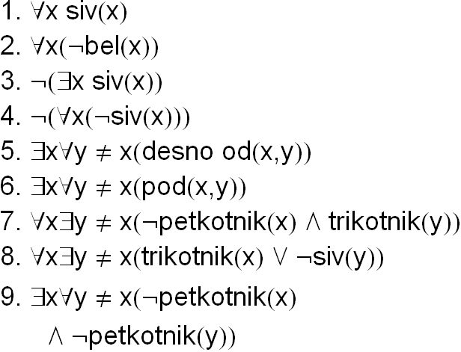C:\Users\mathema\AppData\Local\Microsoft\Windows\Temporary Internet Files\Content.Word\3-4d.wmf

C:\Users\mathema\AppData\Local\Microsoft\Windows\Temporary Internet Files\Content.Word\4-4c.wmfC:\Users\mathema\AppData\Local\Microsoft\Windows\Temporary Internet Files\Content.Word\4-4b.wmf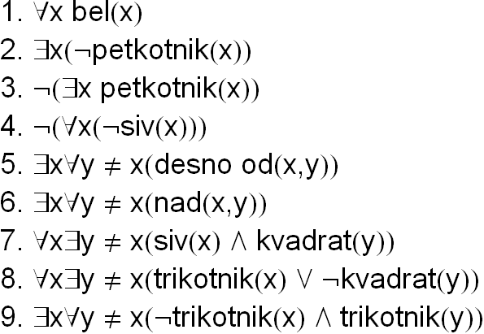

C:\Users\mathema\AppData\Local\Microsoft\Windows\Temporary Internet Files\Content.Word\4-4d.wmf

C:\Users\mathema\AppData\Local\Microsoft\Windows\Temporary Internet Files\Content.Word\5-4c.wmfC:\Users\mathema\AppData\Local\Microsoft\Windows\Temporary Internet Files\Content.Word\5-4b.wmf

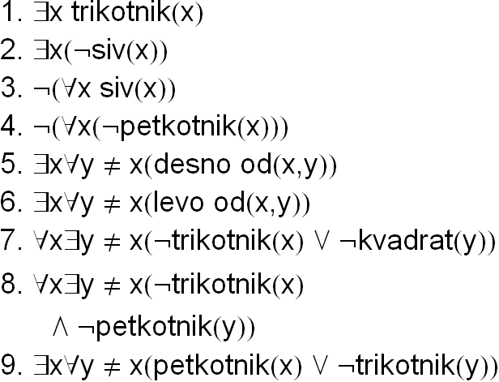C:\Users\mathema\AppData\Local\Microsoft\Windows\Temporary Internet Files\Content.Word\5-4d.wmf

C:\Users\mathema\AppData\Local\Microsoft\Windows\Temporary Internet Files\Content.Word\6-4c.wmfC:\Users\mathema\AppData\Local\Microsoft\Windows\Temporary Internet Files\Content.Word\6-4b.wmf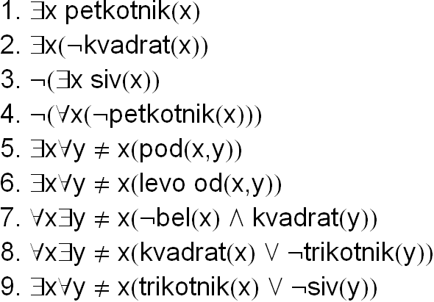C:\Users\mathema\AppData\Local\Microsoft\Windows\Temporary Internet Files\Content.Word\6-4d.wmf

C:\Users\mathema\AppData\Local\Microsoft\Windows\Temporary Internet Files\Content.Word\7-4c.wmfC:\Users\mathema\AppData\Local\Microsoft\Windows\Temporary Internet Files\Content.Word\7-4b.wmf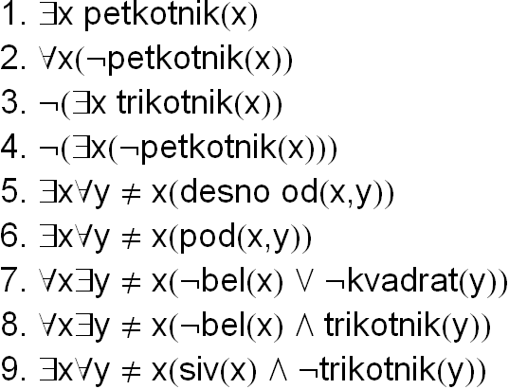

C:\Users\mathema\AppData\Local\Microsoft\Windows\Temporary Internet Files\Content.Word\7-4d.wmf

C:\Users\mathema\AppData\Local\Microsoft\Windows\Temporary Internet Files\Content.Word\8-4c.wmfC:\Users\mathema\AppData\Local\Microsoft\Windows\Temporary Internet Files\Content.Word\8-4b.wmf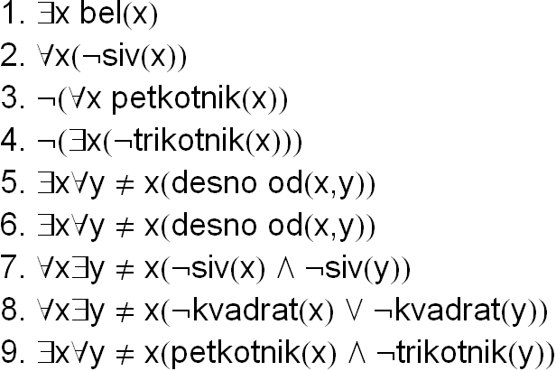

C:\Users\mathema\AppData\Local\Microsoft\Windows\Temporary Internet Files\Content.Word\8-4d.wmf

C:\Users\mathema\AppData\Local\Microsoft\Windows\Temporary Internet Files\Content.Word\9-4c.wmfC:\Users\mathema\AppData\Local\Microsoft\Windows\Temporary Internet Files\Content.Word\9-4b.wmf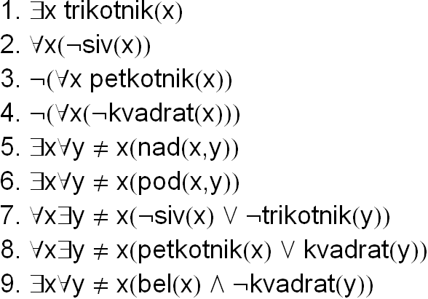C:\Users\mathema\AppData\Local\Microsoft\Windows\Temporary Internet Files\Content.Word\9-4d.wmf

C:\Users\mathema\AppData\Local\Microsoft\Windows\Temporary Internet Files\Content.Word\10-4c.wmfC:\Users\mathema\AppData\Local\Microsoft\Windows\Temporary Internet Files\Content.Word\10-4b.wmf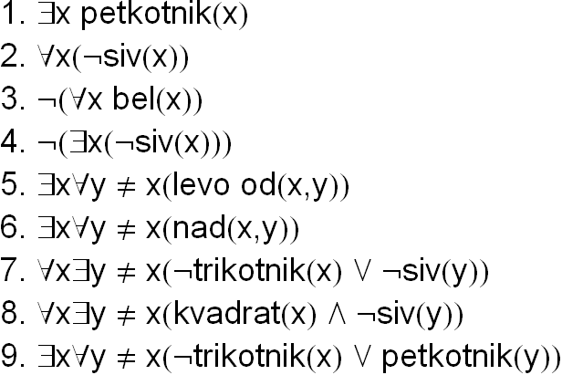C:\Users\mathema\AppData\Local\Microsoft\Windows\Temporary Internet Files\Content.Word\10-4d.wmf