**LOGIČNA POŠAST**

VAJE ZA TEKMOVANJE

**8. IN 9. RAZRED**

SVET (2)

mathema3.jpgC:\Users\mathema\AppData\Local\Microsoft\Windows\Temporary Internet Files\Content.Word\30-4c.wmf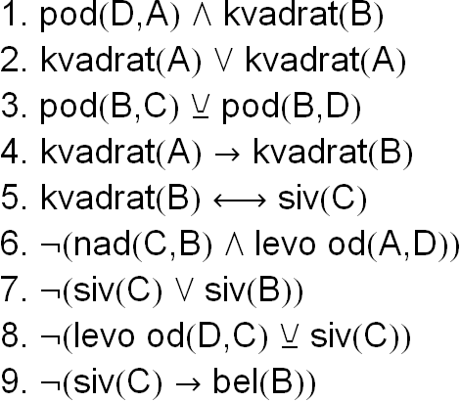

C:\Users\mathema\AppData\Local\Microsoft\Windows\Temporary Internet Files\Content.Word\30-4d.wmfC:\Users\mathema\AppData\Local\Microsoft\Windows\Temporary Internet Files\Content.Word\30-4b.wmf

C:\Users\mathema\AppData\Local\Microsoft\Windows\Temporary Internet Files\Content.Word\29-4c.wmf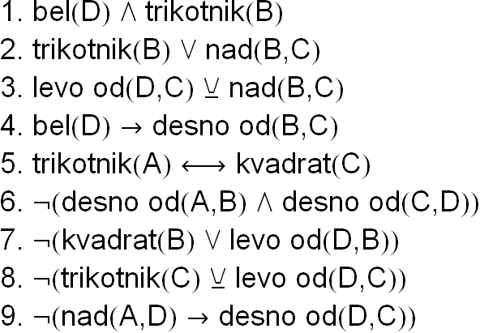C:\Users\mathema\AppData\Local\Microsoft\Windows\Temporary Internet Files\Content.Word\29-4d.wmfC:\Users\mathema\AppData\Local\Microsoft\Windows\Temporary Internet Files\Content.Word\29-4b.wmf

C:\Users\mathema\AppData\Local\Microsoft\Windows\Temporary Internet Files\Content.Word\28-4c.wmf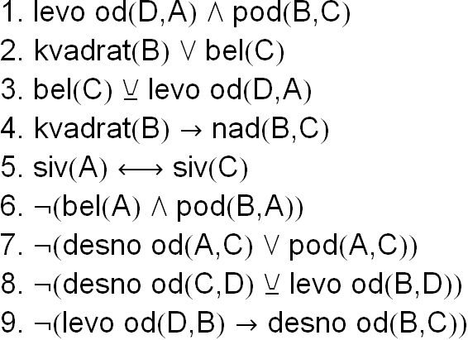C:\Users\mathema\AppData\Local\Microsoft\Windows\Temporary Internet Files\Content.Word\28-4d.wmfC:\Users\mathema\AppData\Local\Microsoft\Windows\Temporary Internet Files\Content.Word\28-4b.wmf

C:\Users\mathema\AppData\Local\Microsoft\Windows\Temporary Internet Files\Content.Word\27-4c.wmf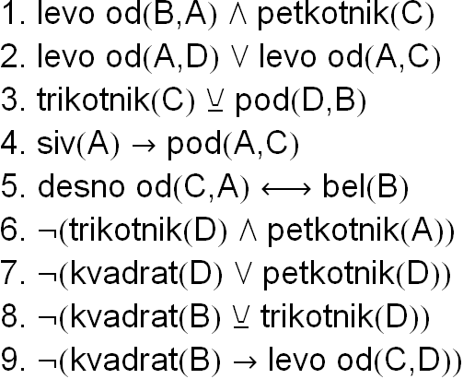C:\Users\mathema\AppData\Local\Microsoft\Windows\Temporary Internet Files\Content.Word\27-4d.wmfC:\Users\mathema\AppData\Local\Microsoft\Windows\Temporary Internet Files\Content.Word\27-4b.wmf

C:\Users\mathema\AppData\Local\Microsoft\Windows\Temporary Internet Files\Content.Word\26-4c.wmf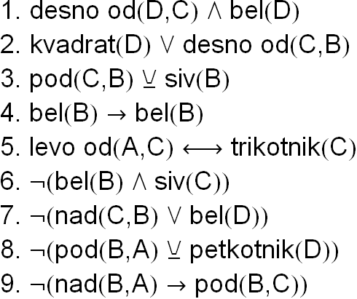

C:\Users\mathema\AppData\Local\Microsoft\Windows\Temporary Internet Files\Content.Word\26-4d.wmfC:\Users\mathema\AppData\Local\Microsoft\Windows\Temporary Internet Files\Content.Word\26-4b.wmf

C:\Users\mathema\AppData\Local\Microsoft\Windows\Temporary Internet Files\Content.Word\25-4c.wmf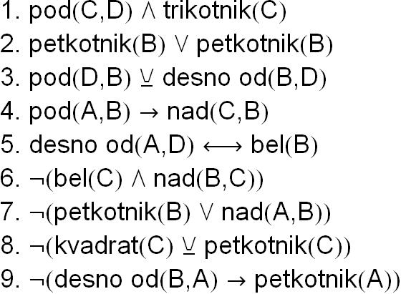C:\Users\mathema\AppData\Local\Microsoft\Windows\Temporary Internet Files\Content.Word\25-4d.wmfC:\Users\mathema\AppData\Local\Microsoft\Windows\Temporary Internet Files\Content.Word\25-4b.wmf

C:\Users\mathema\AppData\Local\Microsoft\Windows\Temporary Internet Files\Content.Word\24-4c.wmf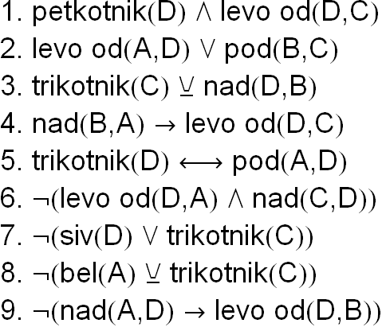

C:\Users\mathema\AppData\Local\Microsoft\Windows\Temporary Internet Files\Content.Word\24-4d.wmfC:\Users\mathema\AppData\Local\Microsoft\Windows\Temporary Internet Files\Content.Word\24-4b.wmf

C:\Users\mathema\AppData\Local\Microsoft\Windows\Temporary Internet Files\Content.Word\23-4c.wmf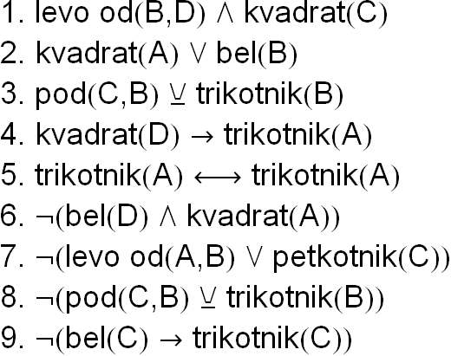C:\Users\mathema\AppData\Local\Microsoft\Windows\Temporary Internet Files\Content.Word\23-4d.wmfC:\Users\mathema\AppData\Local\Microsoft\Windows\Temporary Internet Files\Content.Word\23-4b.wmf

C:\Users\mathema\AppData\Local\Microsoft\Windows\Temporary Internet Files\Content.Word\22-4c.wmf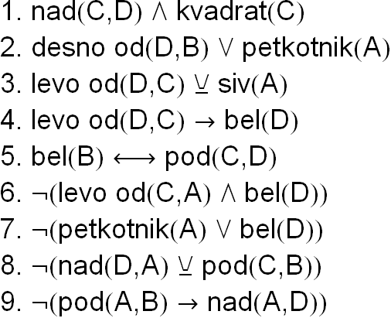C:\Users\mathema\AppData\Local\Microsoft\Windows\Temporary Internet Files\Content.Word\22-4d.wmfC:\Users\mathema\AppData\Local\Microsoft\Windows\Temporary Internet Files\Content.Word\22-4b.wmf

C:\Users\mathema\AppData\Local\Microsoft\Windows\Temporary Internet Files\Content.Word\21-4c.wmf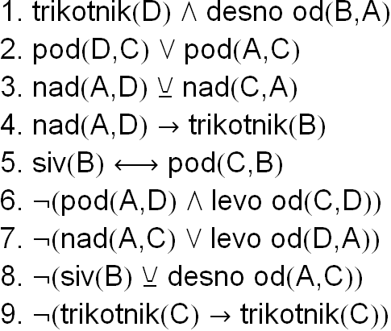

C:\Users\mathema\AppData\Local\Microsoft\Windows\Temporary Internet Files\Content.Word\21-4d.wmfC:\Users\mathema\AppData\Local\Microsoft\Windows\Temporary Internet Files\Content.Word\21-4b.wmf

C:\Users\mathema\AppData\Local\Microsoft\Windows\Temporary Internet Files\Content.Word\20-4c.wmf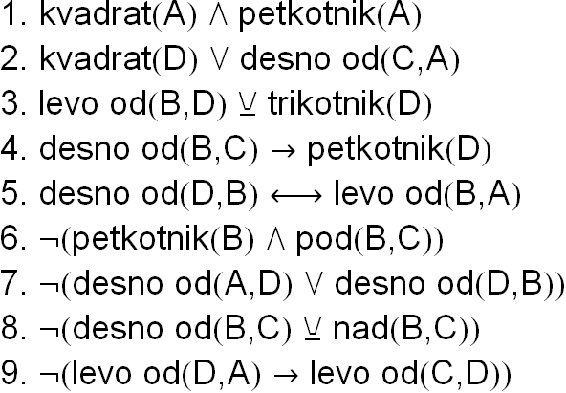C:\Users\mathema\AppData\Local\Microsoft\Windows\Temporary Internet Files\Content.Word\20-4d.wmfC:\Users\mathema\AppData\Local\Microsoft\Windows\Temporary Internet Files\Content.Word\20-4b.wmf

C:\Users\mathema\AppData\Local\Microsoft\Windows\Temporary Internet Files\Content.Word\19-4c.wmf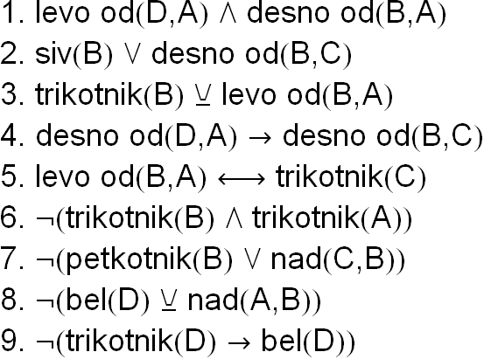C:\Users\mathema\AppData\Local\Microsoft\Windows\Temporary Internet Files\Content.Word\19-4d.wmfC:\Users\mathema\AppData\Local\Microsoft\Windows\Temporary Internet Files\Content.Word\19-4b.wmf

C:\Users\mathema\AppData\Local\Microsoft\Windows\Temporary Internet Files\Content.Word\18-4c.wmf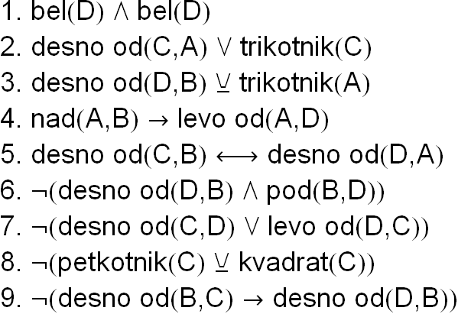C:\Users\mathema\AppData\Local\Microsoft\Windows\Temporary Internet Files\Content.Word\18-4d.wmfC:\Users\mathema\AppData\Local\Microsoft\Windows\Temporary Internet Files\Content.Word\18-4b.wmf

C:\Users\mathema\AppData\Local\Microsoft\Windows\Temporary Internet Files\Content.Word\17-4c.wmf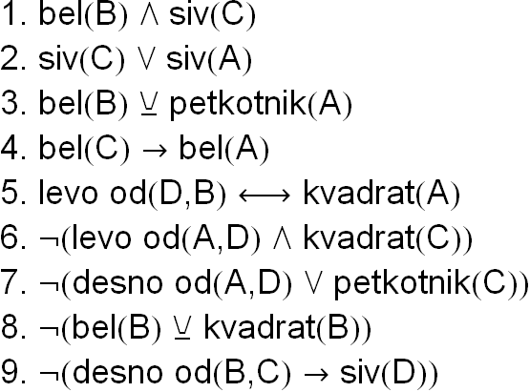C:\Users\mathema\AppData\Local\Microsoft\Windows\Temporary Internet Files\Content.Word\17-4d.wmfC:\Users\mathema\AppData\Local\Microsoft\Windows\Temporary Internet Files\Content.Word\17-4b.wmf

C:\Users\mathema\AppData\Local\Microsoft\Windows\Temporary Internet Files\Content.Word\16-4c.wmf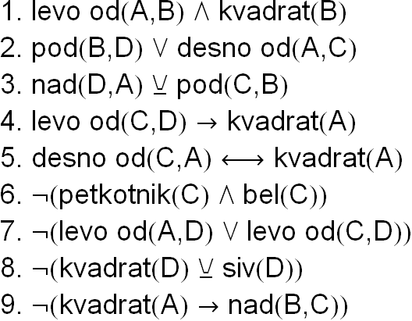C:\Users\mathema\AppData\Local\Microsoft\Windows\Temporary Internet Files\Content.Word\16-4d.wmfC:\Users\mathema\AppData\Local\Microsoft\Windows\Temporary Internet Files\Content.Word\16-4b.wmf

C:\Users\mathema\AppData\Local\Microsoft\Windows\Temporary Internet Files\Content.Word\15-4c.wmf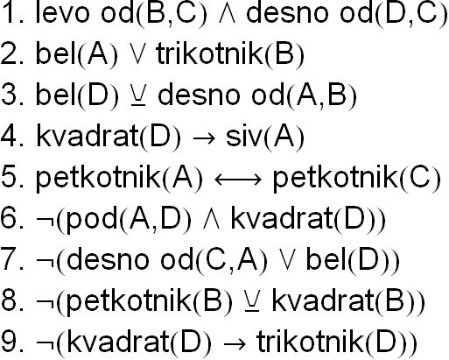C:\Users\mathema\AppData\Local\Microsoft\Windows\Temporary Internet Files\Content.Word\15-4d.wmfC:\Users\mathema\AppData\Local\Microsoft\Windows\Temporary Internet Files\Content.Word\15-4b.wmf

C:\Users\mathema\AppData\Local\Microsoft\Windows\Temporary Internet Files\Content.Word\14-4c.wmf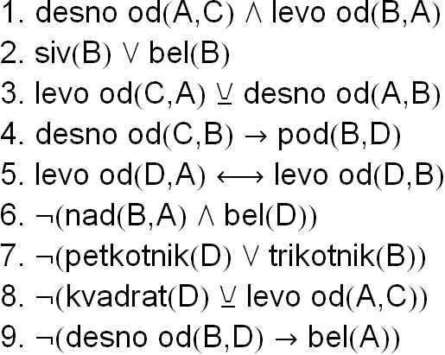C:\Users\mathema\AppData\Local\Microsoft\Windows\Temporary Internet Files\Content.Word\14-4d.wmfC:\Users\mathema\AppData\Local\Microsoft\Windows\Temporary Internet Files\Content.Word\14-4b.wmf

C:\Users\mathema\AppData\Local\Microsoft\Windows\Temporary Internet Files\Content.Word\13-4c.wmf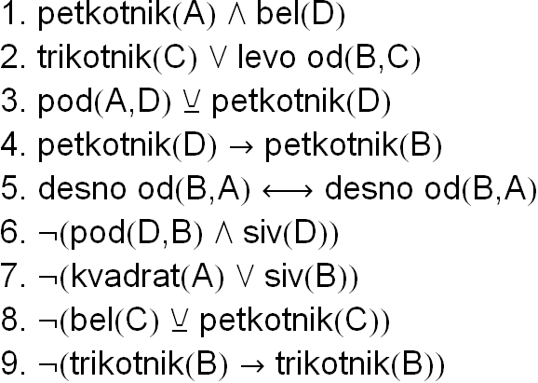C:\Users\mathema\AppData\Local\Microsoft\Windows\Temporary Internet Files\Content.Word\13-4d.wmfC:\Users\mathema\AppData\Local\Microsoft\Windows\Temporary Internet Files\Content.Word\13-4b.wmf

C:\Users\mathema\AppData\Local\Microsoft\Windows\Temporary Internet Files\Content.Word\12-4c.wmf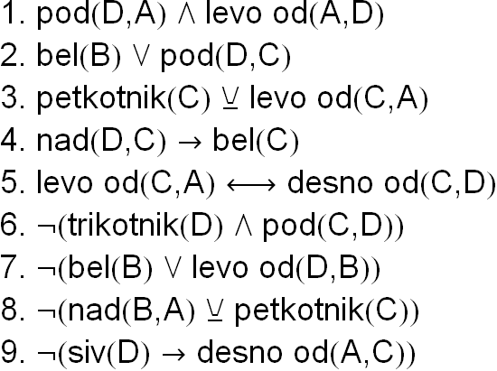C:\Users\mathema\AppData\Local\Microsoft\Windows\Temporary Internet Files\Content.Word\12-4d.wmfC:\Users\mathema\AppData\Local\Microsoft\Windows\Temporary Internet Files\Content.Word\12-4b.wmf

C:\Users\mathema\AppData\Local\Microsoft\Windows\Temporary Internet Files\Content.Word\11-4c.wmf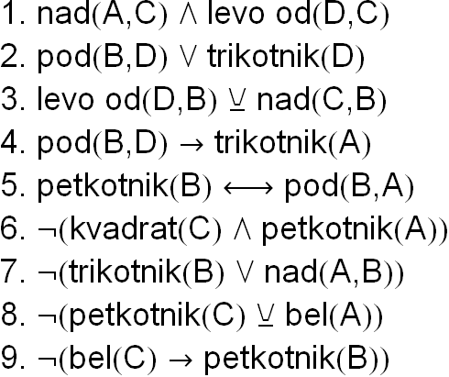

C:\Users\mathema\AppData\Local\Microsoft\Windows\Temporary Internet Files\Content.Word\11-4d.wmfC:\Users\mathema\AppData\Local\Microsoft\Windows\Temporary Internet Files\Content.Word\11-4b.wmf

C:\Users\mathema\AppData\Local\Microsoft\Windows\Temporary Internet Files\Content.Word\10-4c.wmf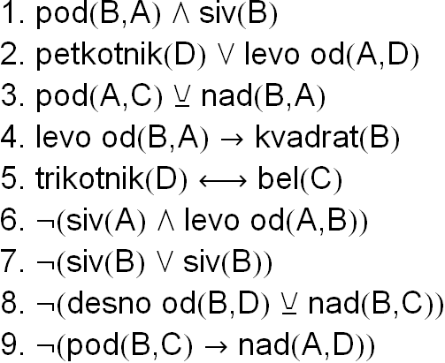C:\Users\mathema\AppData\Local\Microsoft\Windows\Temporary Internet Files\Content.Word\10-4d.wmfC:\Users\mathema\AppData\Local\Microsoft\Windows\Temporary Internet Files\Content.Word\10-4b.wmf

C:\Users\mathema\AppData\Local\Microsoft\Windows\Temporary Internet Files\Content.Word\9-4c.wmf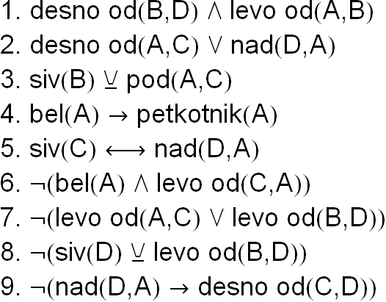C:\Users\mathema\AppData\Local\Microsoft\Windows\Temporary Internet Files\Content.Word\9-4d.wmfC:\Users\mathema\AppData\Local\Microsoft\Windows\Temporary Internet Files\Content.Word\9-4b.wmf

C:\Users\mathema\AppData\Local\Microsoft\Windows\Temporary Internet Files\Content.Word\8-4c.wmf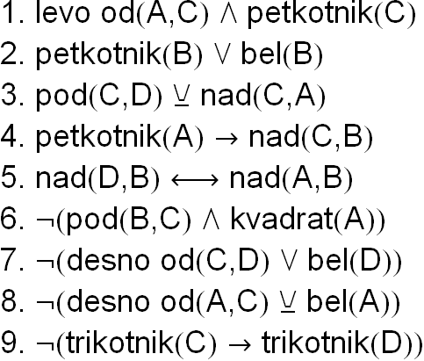

C:\Users\mathema\AppData\Local\Microsoft\Windows\Temporary Internet Files\Content.Word\8-4d.wmfC:\Users\mathema\AppData\Local\Microsoft\Windows\Temporary Internet Files\Content.Word\8-4b.wmf

C:\Users\mathema\AppData\Local\Microsoft\Windows\Temporary Internet Files\Content.Word\7-4c.wmf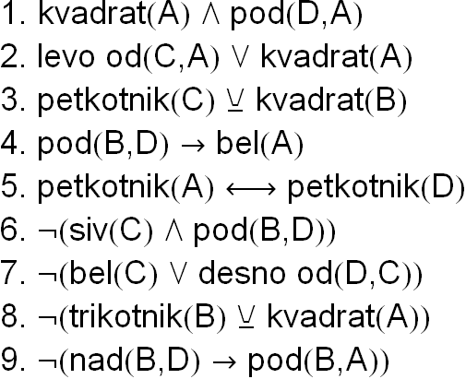C:\Users\mathema\AppData\Local\Microsoft\Windows\Temporary Internet Files\Content.Word\7-4d.wmfC:\Users\mathema\AppData\Local\Microsoft\Windows\Temporary Internet Files\Content.Word\7-4b.wmf

C:\Users\mathema\AppData\Local\Microsoft\Windows\Temporary Internet Files\Content.Word\6-4c.wmf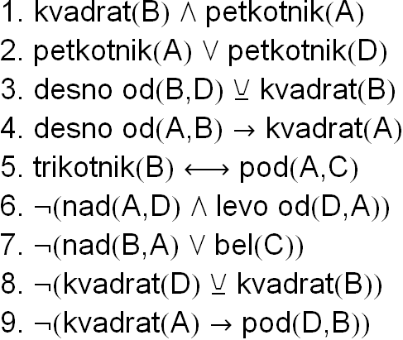

C:\Users\mathema\AppData\Local\Microsoft\Windows\Temporary Internet Files\Content.Word\6-4d.wmfC:\Users\mathema\AppData\Local\Microsoft\Windows\Temporary Internet Files\Content.Word\6-4b.wmf

C:\Users\mathema\AppData\Local\Microsoft\Windows\Temporary Internet Files\Content.Word\5-4c.wmf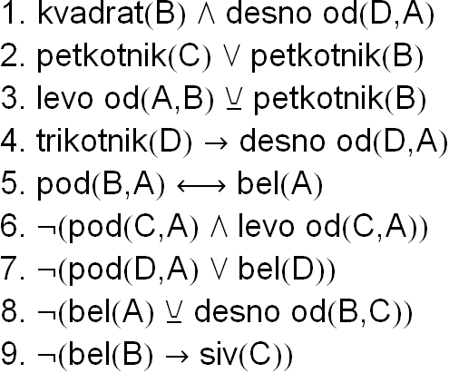

C:\Users\mathema\AppData\Local\Microsoft\Windows\Temporary Internet Files\Content.Word\5-4d.wmfC:\Users\mathema\AppData\Local\Microsoft\Windows\Temporary Internet Files\Content.Word\5-4b.wmf

C:\Users\mathema\AppData\Local\Microsoft\Windows\Temporary Internet Files\Content.Word\4-4c.wmf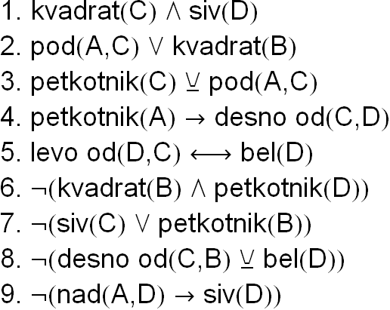C:\Users\mathema\AppData\Local\Microsoft\Windows\Temporary Internet Files\Content.Word\4-4d.wmfC:\Users\mathema\AppData\Local\Microsoft\Windows\Temporary Internet Files\Content.Word\4-4b.wmf

C:\Users\mathema\AppData\Local\Microsoft\Windows\Temporary Internet Files\Content.Word\3-4c.wmf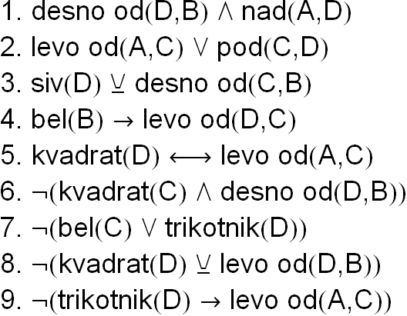C:\Users\mathema\AppData\Local\Microsoft\Windows\Temporary Internet Files\Content.Word\3-4d.wmfC:\Users\mathema\AppData\Local\Microsoft\Windows\Temporary Internet Files\Content.Word\3-4b.wmf

C:\Users\mathema\AppData\Local\Microsoft\Windows\Temporary Internet Files\Content.Word\2-4c.wmf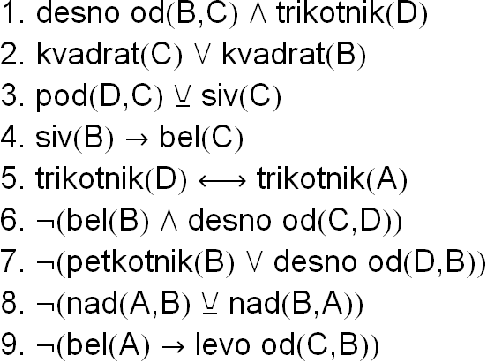C:\Users\mathema\AppData\Local\Microsoft\Windows\Temporary Internet Files\Content.Word\2-4d.wmfC:\Users\mathema\AppData\Local\Microsoft\Windows\Temporary Internet Files\Content.Word\2-4b.wmf

C:\Users\mathema\AppData\Local\Microsoft\Windows\Temporary Internet Files\Content.Word\1-4c.wmf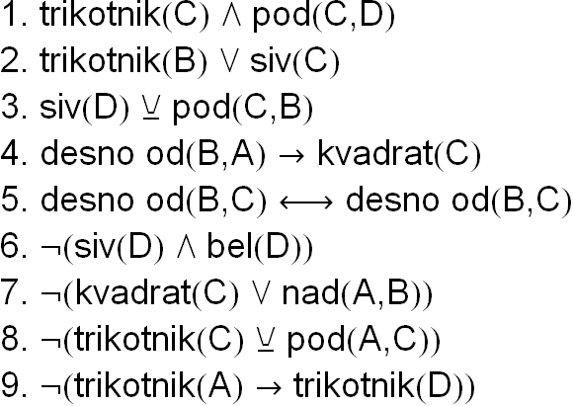C:\Users\mathema\AppData\Local\Microsoft\Windows\Temporary Internet Files\Content.Word\1-4d.wmfC:\Users\mathema\AppData\Local\Microsoft\Windows\Temporary Internet Files\Content.Word\1-4b.wmf