LOGIČNA POŠAST

VAJE ZA TEKMOVANJE

8 IN 9. RAZRED

OBRATNI SVET TARSKEGA

(3)

mathema3.jpg**Naloga:**

Podani so stavki in njihova pravilnost (R-resničen, N-neresničen). Stavki določajo like na desni. Določi jih (označi jih s črkami, A, B, C, D, …)

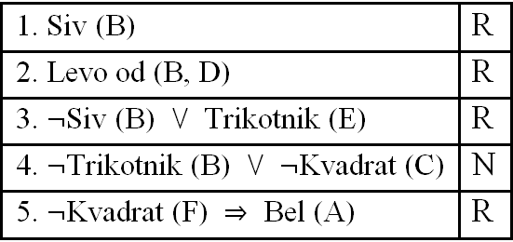C:\Users\mathema\AppData\Local\Microsoft\Windows\Temporary Internet Files\Content.Word\101-6-5q.wmf

**Rešitev:**

C:\Users\mathema\AppData\Local\Microsoft\Windows\Temporary Internet Files\Content.Word\101-6-5a.wmf

C:\Users\mathema\AppData\Local\Microsoft\Windows\Temporary Internet Files\Content.Word\101-6-5q.wmfC:\Users\mathema\AppData\Local\Microsoft\Windows\Temporary Internet Files\Content.Word\101-6-5a.wmf

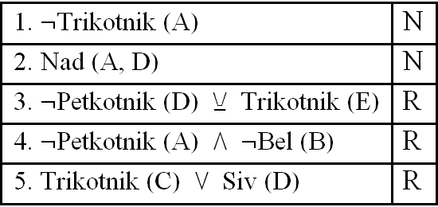C:\Users\mathema\AppData\Local\Microsoft\Windows\Temporary Internet Files\Content.Word\101-5-5q.wmf

C:\Users\mathema\AppData\Local\Microsoft\Windows\Temporary Internet Files\Content.Word\101-5-5a.wmf

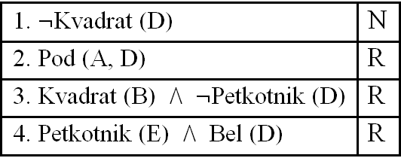C:\Users\mathema\AppData\Local\Microsoft\Windows\Temporary Internet Files\Content.Word\101-5-4q.wmf

C:\Users\mathema\AppData\Local\Microsoft\Windows\Temporary Internet Files\Content.Word\101-5-4a.wmf

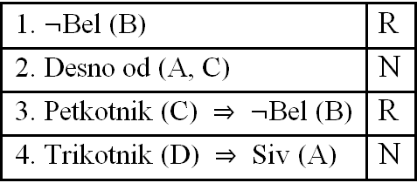C:\Users\mathema\AppData\Local\Microsoft\Windows\Temporary Internet Files\Content.Word\101-4-4q.wmf

C:\Users\mathema\AppData\Local\Microsoft\Windows\Temporary Internet Files\Content.Word\101-4-4a.wmf

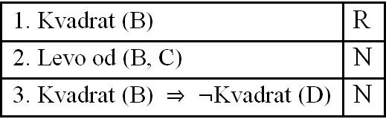C:\Users\mathema\AppData\Local\Microsoft\Windows\Temporary Internet Files\Content.Word\101-4-3q.wmf

C:\Users\mathema\AppData\Local\Microsoft\Windows\Temporary Internet Files\Content.Word\101-4-3a.wmf

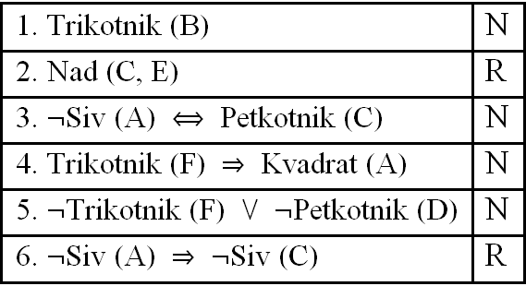C:\Users\mathema\AppData\Local\Microsoft\Windows\Temporary Internet Files\Content.Word\120-6-6q.wmf

C:\Users\mathema\AppData\Local\Microsoft\Windows\Temporary Internet Files\Content.Word\120-6-6a.wmf

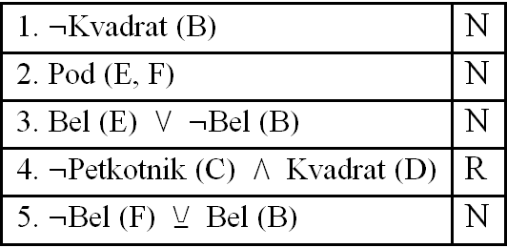C:\Users\mathema\AppData\Local\Microsoft\Windows\Temporary Internet Files\Content.Word\120-6-5q.wmf

C:\Users\mathema\AppData\Local\Microsoft\Windows\Temporary Internet Files\Content.Word\120-6-5a.wmf

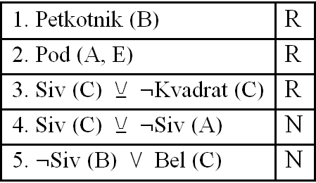C:\Users\mathema\AppData\Local\Microsoft\Windows\Temporary Internet Files\Content.Word\120-5-5q.wmf

C:\Users\mathema\AppData\Local\Microsoft\Windows\Temporary Internet Files\Content.Word\120-5-5a.wmf

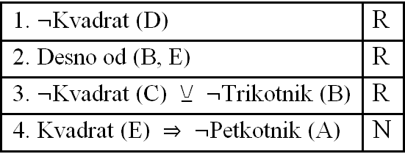C:\Users\mathema\AppData\Local\Microsoft\Windows\Temporary Internet Files\Content.Word\120-5-4q.wmf

C:\Users\mathema\AppData\Local\Microsoft\Windows\Temporary Internet Files\Content.Word\120-5-4a.wmf

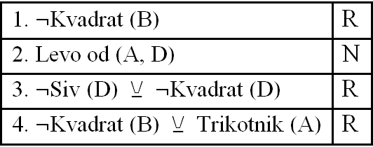C:\Users\mathema\AppData\Local\Microsoft\Windows\Temporary Internet Files\Content.Word\120-4-4q.wmf

C:\Users\mathema\AppData\Local\Microsoft\Windows\Temporary Internet Files\Content.Word\120-4-4a.wmf

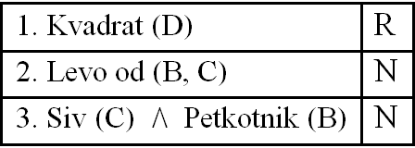C:\Users\mathema\AppData\Local\Microsoft\Windows\Temporary Internet Files\Content.Word\120-4-3q.wmf

C:\Users\mathema\AppData\Local\Microsoft\Windows\Temporary Internet Files\Content.Word\120-4-3a.wmf

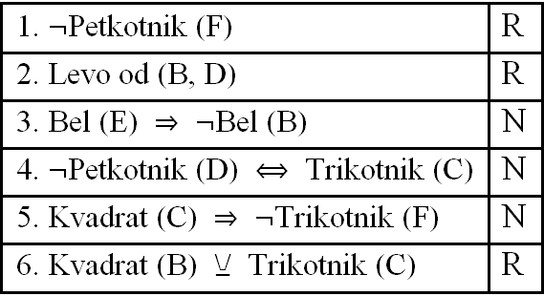C:\Users\mathema\AppData\Local\Microsoft\Windows\Temporary Internet Files\Content.Word\119-6-6q.wmf

C:\Users\mathema\AppData\Local\Microsoft\Windows\Temporary Internet Files\Content.Word\119-6-6a.wmf

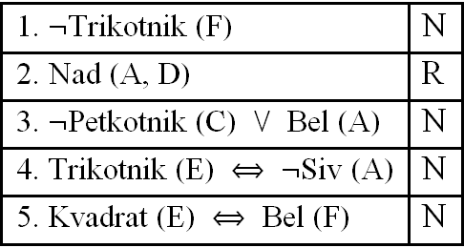C:\Users\mathema\AppData\Local\Microsoft\Windows\Temporary Internet Files\Content.Word\119-6-5q.wmf

C:\Users\mathema\AppData\Local\Microsoft\Windows\Temporary Internet Files\Content.Word\119-6-5a.wmf

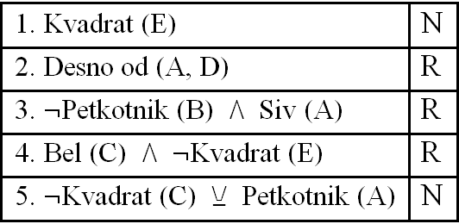C:\Users\mathema\AppData\Local\Microsoft\Windows\Temporary Internet Files\Content.Word\119-5-5q.wmf

C:\Users\mathema\AppData\Local\Microsoft\Windows\Temporary Internet Files\Content.Word\119-5-5a.wmf

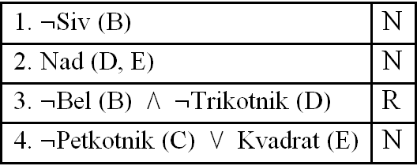C:\Users\mathema\AppData\Local\Microsoft\Windows\Temporary Internet Files\Content.Word\119-5-4q.wmf

C:\Users\mathema\AppData\Local\Microsoft\Windows\Temporary Internet Files\Content.Word\119-5-4a.wmf

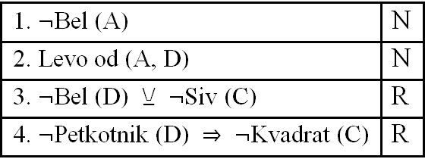C:\Users\mathema\AppData\Local\Microsoft\Windows\Temporary Internet Files\Content.Word\119-4-4q.wmf

C:\Users\mathema\AppData\Local\Microsoft\Windows\Temporary Internet Files\Content.Word\119-4-4a.wmf

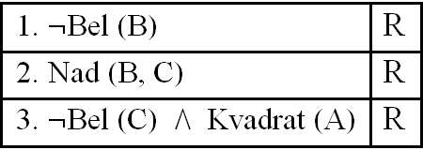C:\Users\mathema\AppData\Local\Microsoft\Windows\Temporary Internet Files\Content.Word\119-4-3q.wmf

C:\Users\mathema\AppData\Local\Microsoft\Windows\Temporary Internet Files\Content.Word\119-4-3a.wmf

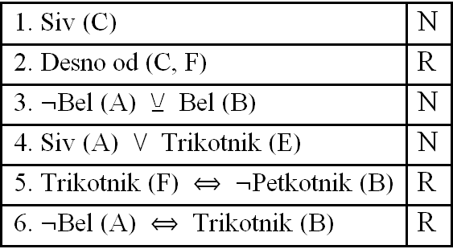C:\Users\mathema\AppData\Local\Microsoft\Windows\Temporary Internet Files\Content.Word\118-6-6q.wmf

C:\Users\mathema\AppData\Local\Microsoft\Windows\Temporary Internet Files\Content.Word\118-6-6a.wmf

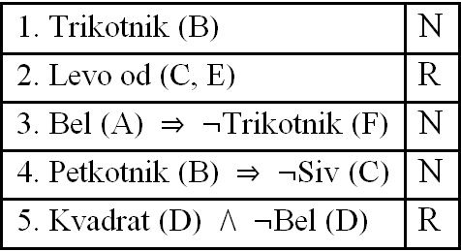C:\Users\mathema\AppData\Local\Microsoft\Windows\Temporary Internet Files\Content.Word\118-6-5q.wmf

C:\Users\mathema\AppData\Local\Microsoft\Windows\Temporary Internet Files\Content.Word\118-6-5a.wmf

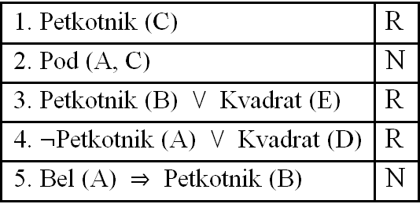C:\Users\mathema\AppData\Local\Microsoft\Windows\Temporary Internet Files\Content.Word\118-5-5q.wmf

C:\Users\mathema\AppData\Local\Microsoft\Windows\Temporary Internet Files\Content.Word\118-5-5a.wmf

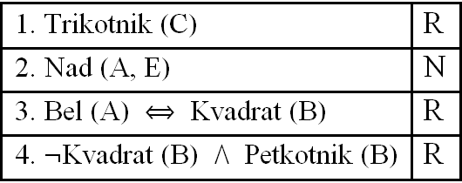C:\Users\mathema\AppData\Local\Microsoft\Windows\Temporary Internet Files\Content.Word\118-5-4q.wmf

C:\Users\mathema\AppData\Local\Microsoft\Windows\Temporary Internet Files\Content.Word\118-5-4a.wmf

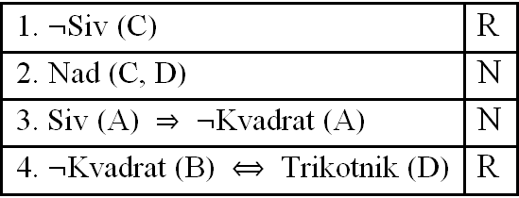C:\Users\mathema\AppData\Local\Microsoft\Windows\Temporary Internet Files\Content.Word\118-4-4q.wmf

C:\Users\mathema\AppData\Local\Microsoft\Windows\Temporary Internet Files\Content.Word\118-4-4a.wmf

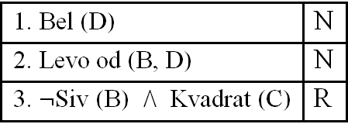C:\Users\mathema\AppData\Local\Microsoft\Windows\Temporary Internet Files\Content.Word\118-4-3q.wmf

C:\Users\mathema\AppData\Local\Microsoft\Windows\Temporary Internet Files\Content.Word\118-4-3a.wmf

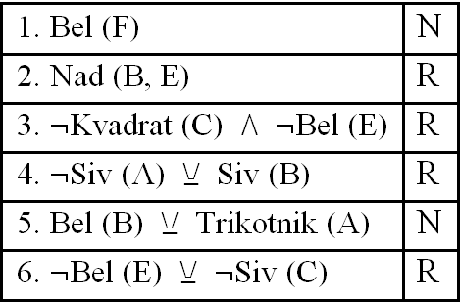C:\Users\mathema\AppData\Local\Microsoft\Windows\Temporary Internet Files\Content.Word\117-6-6q.wmf

C:\Users\mathema\AppData\Local\Microsoft\Windows\Temporary Internet Files\Content.Word\117-6-6a.wmf

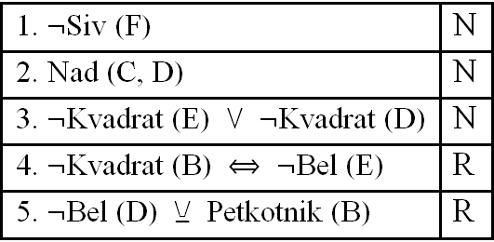C:\Users\mathema\AppData\Local\Microsoft\Windows\Temporary Internet Files\Content.Word\117-6-5q.wmf

C:\Users\mathema\AppData\Local\Microsoft\Windows\Temporary Internet Files\Content.Word\117-6-5a.wmf

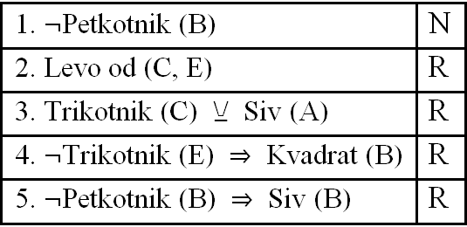C:\Users\mathema\AppData\Local\Microsoft\Windows\Temporary Internet Files\Content.Word\117-5-5q.wmf

C:\Users\mathema\AppData\Local\Microsoft\Windows\Temporary Internet Files\Content.Word\117-5-5a.wmf

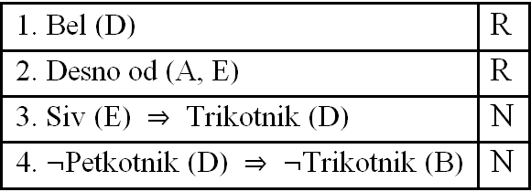C:\Users\mathema\AppData\Local\Microsoft\Windows\Temporary Internet Files\Content.Word\117-5-4q.wmf

C:\Users\mathema\AppData\Local\Microsoft\Windows\Temporary Internet Files\Content.Word\117-5-4a.wmf

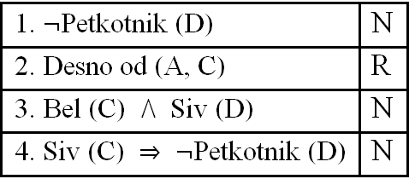C:\Users\mathema\AppData\Local\Microsoft\Windows\Temporary Internet Files\Content.Word\117-4-4q.wmf

C:\Users\mathema\AppData\Local\Microsoft\Windows\Temporary Internet Files\Content.Word\117-4-4a.wmf

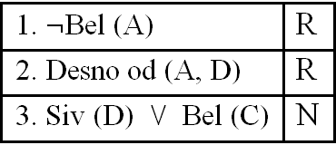C:\Users\mathema\AppData\Local\Microsoft\Windows\Temporary Internet Files\Content.Word\117-4-3q.wmf

C:\Users\mathema\AppData\Local\Microsoft\Windows\Temporary Internet Files\Content.Word\117-4-3a.wmf

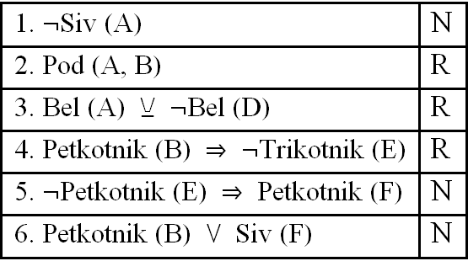C:\Users\mathema\AppData\Local\Microsoft\Windows\Temporary Internet Files\Content.Word\116-6-6q.wmf

C:\Users\mathema\AppData\Local\Microsoft\Windows\Temporary Internet Files\Content.Word\116-6-6a.wmf

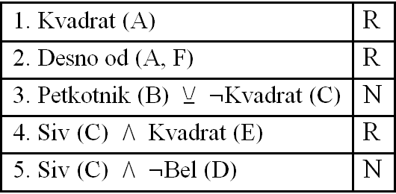C:\Users\mathema\AppData\Local\Microsoft\Windows\Temporary Internet Files\Content.Word\116-6-5q.wmf

C:\Users\mathema\AppData\Local\Microsoft\Windows\Temporary Internet Files\Content.Word\116-6-5a.wmf

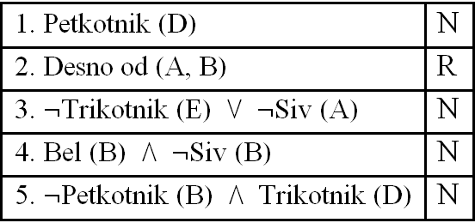C:\Users\mathema\AppData\Local\Microsoft\Windows\Temporary Internet Files\Content.Word\116-5-5q.wmf

C:\Users\mathema\AppData\Local\Microsoft\Windows\Temporary Internet Files\Content.Word\116-5-5a.wmf

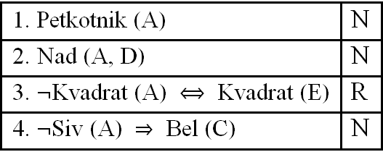C:\Users\mathema\AppData\Local\Microsoft\Windows\Temporary Internet Files\Content.Word\116-5-4q.wmf

C:\Users\mathema\AppData\Local\Microsoft\Windows\Temporary Internet Files\Content.Word\116-5-4a.wmf

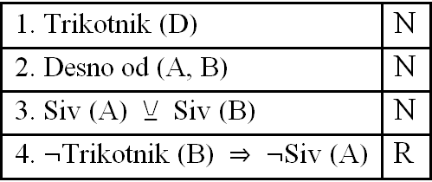C:\Users\mathema\AppData\Local\Microsoft\Windows\Temporary Internet Files\Content.Word\116-4-4q.wmf

C:\Users\mathema\AppData\Local\Microsoft\Windows\Temporary Internet Files\Content.Word\116-4-4a.wmf

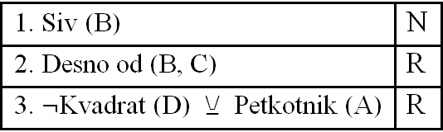C:\Users\mathema\AppData\Local\Microsoft\Windows\Temporary Internet Files\Content.Word\116-4-3q.wmf

C:\Users\mathema\AppData\Local\Microsoft\Windows\Temporary Internet Files\Content.Word\116-4-3a.wmf

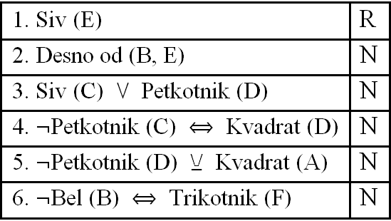C:\Users\mathema\AppData\Local\Microsoft\Windows\Temporary Internet Files\Content.Word\115-6-6q.wmf

C:\Users\mathema\AppData\Local\Microsoft\Windows\Temporary Internet Files\Content.Word\115-6-6a.wmf

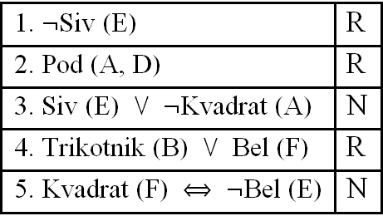C:\Users\mathema\AppData\Local\Microsoft\Windows\Temporary Internet Files\Content.Word\115-6-5q.wmf

C:\Users\mathema\AppData\Local\Microsoft\Windows\Temporary Internet Files\Content.Word\115-6-5a.wmf

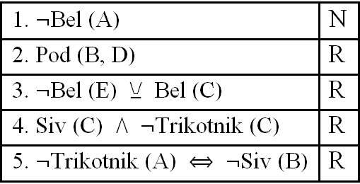C:\Users\mathema\AppData\Local\Microsoft\Windows\Temporary Internet Files\Content.Word\115-5-5q.wmf

C:\Users\mathema\AppData\Local\Microsoft\Windows\Temporary Internet Files\Content.Word\115-5-5a.wmf

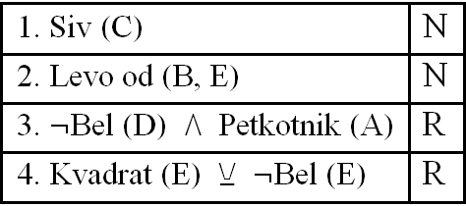C:\Users\mathema\AppData\Local\Microsoft\Windows\Temporary Internet Files\Content.Word\115-5-4q.wmf

C:\Users\mathema\AppData\Local\Microsoft\Windows\Temporary Internet Files\Content.Word\115-5-4a.wmf

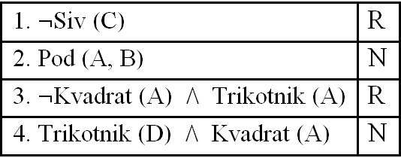C:\Users\mathema\AppData\Local\Microsoft\Windows\Temporary Internet Files\Content.Word\115-4-4q.wmf

C:\Users\mathema\AppData\Local\Microsoft\Windows\Temporary Internet Files\Content.Word\115-4-4a.wmf

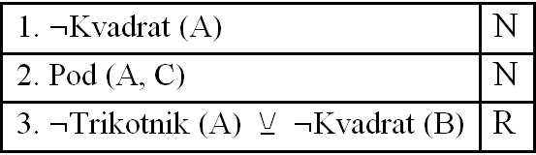C:\Users\mathema\AppData\Local\Microsoft\Windows\Temporary Internet Files\Content.Word\115-4-3q.wmf

C:\Users\mathema\AppData\Local\Microsoft\Windows\Temporary Internet Files\Content.Word\115-4-3a.wmf

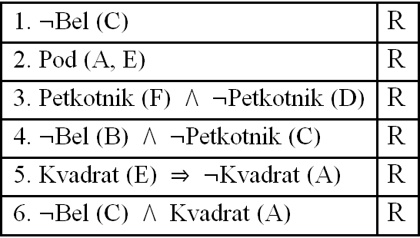C:\Users\mathema\AppData\Local\Microsoft\Windows\Temporary Internet Files\Content.Word\114-6-6q.wmf

C:\Users\mathema\AppData\Local\Microsoft\Windows\Temporary Internet Files\Content.Word\114-6-6a.wmf

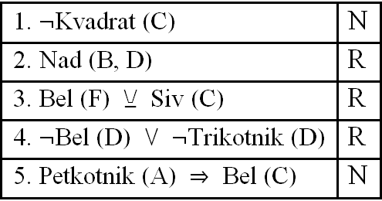C:\Users\mathema\AppData\Local\Microsoft\Windows\Temporary Internet Files\Content.Word\114-6-5q.wmfC:\Users\mathema\AppData\Local\Microsoft\Windows\Temporary Internet Files\Content.Word\114-6-5a.wmf

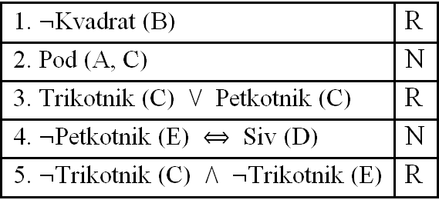C:\Users\mathema\AppData\Local\Microsoft\Windows\Temporary Internet Files\Content.Word\114-5-5q.wmf

C:\Users\mathema\AppData\Local\Microsoft\Windows\Temporary Internet Files\Content.Word\114-5-5a.wmf

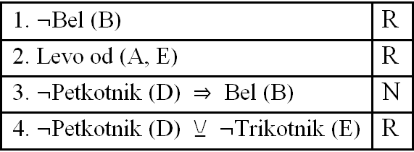C:\Users\mathema\AppData\Local\Microsoft\Windows\Temporary Internet Files\Content.Word\114-5-4q.wmf

C:\Users\mathema\AppData\Local\Microsoft\Windows\Temporary Internet Files\Content.Word\114-5-4a.wmf

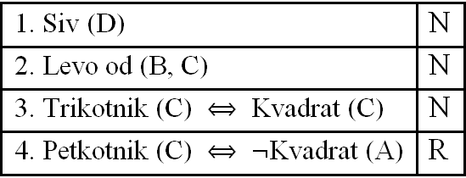C:\Users\mathema\AppData\Local\Microsoft\Windows\Temporary Internet Files\Content.Word\114-4-4q.wmf

C:\Users\mathema\AppData\Local\Microsoft\Windows\Temporary Internet Files\Content.Word\114-4-4a.wmf

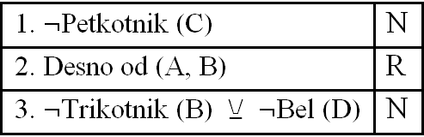C:\Users\mathema\AppData\Local\Microsoft\Windows\Temporary Internet Files\Content.Word\114-4-3q.wmf

C:\Users\mathema\AppData\Local\Microsoft\Windows\Temporary Internet Files\Content.Word\114-4-3a.wmf

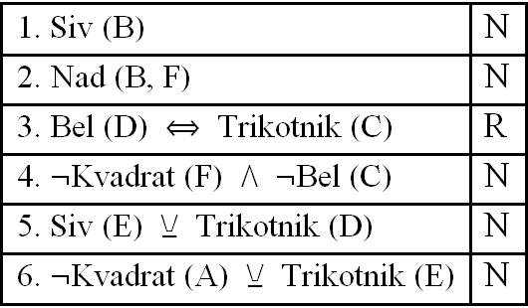C:\Users\mathema\AppData\Local\Microsoft\Windows\Temporary Internet Files\Content.Word\113-6-6q.wmf

C:\Users\mathema\AppData\Local\Microsoft\Windows\Temporary Internet Files\Content.Word\113-6-6a.wmf

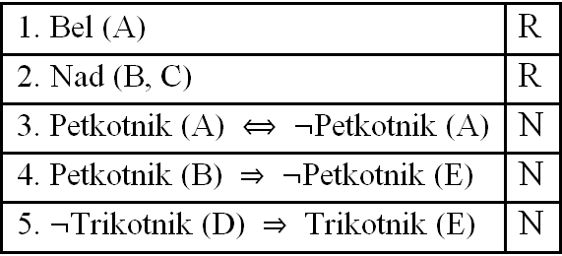C:\Users\mathema\AppData\Local\Microsoft\Windows\Temporary Internet Files\Content.Word\113-6-5q.wmf

C:\Users\mathema\AppData\Local\Microsoft\Windows\Temporary Internet Files\Content.Word\113-6-5a.wmf

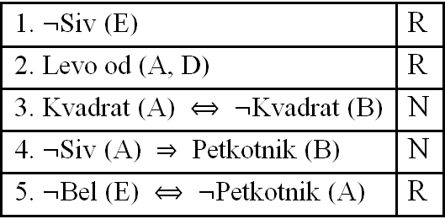C:\Users\mathema\AppData\Local\Microsoft\Windows\Temporary Internet Files\Content.Word\113-5-5q.wmf

C:\Users\mathema\AppData\Local\Microsoft\Windows\Temporary Internet Files\Content.Word\113-5-5a.wmf

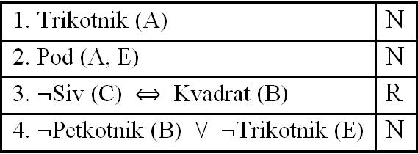C:\Users\mathema\AppData\Local\Microsoft\Windows\Temporary Internet Files\Content.Word\113-5-4q.wmf

C:\Users\mathema\AppData\Local\Microsoft\Windows\Temporary Internet Files\Content.Word\113-5-4a.wmf

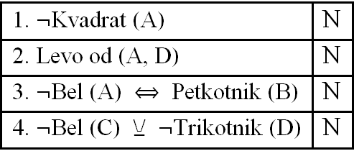C:\Users\mathema\AppData\Local\Microsoft\Windows\Temporary Internet Files\Content.Word\113-4-4q.wmf

C:\Users\mathema\AppData\Local\Microsoft\Windows\Temporary Internet Files\Content.Word\113-4-4a.wmf

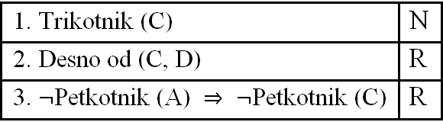C:\Users\mathema\AppData\Local\Microsoft\Windows\Temporary Internet Files\Content.Word\113-4-3q.wmf

C:\Users\mathema\AppData\Local\Microsoft\Windows\Temporary Internet Files\Content.Word\113-4-3a.wmf

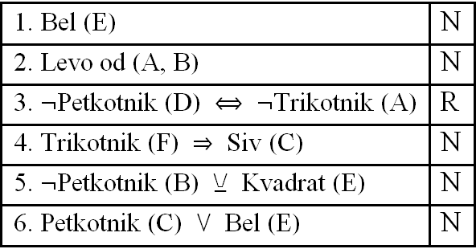C:\Users\mathema\AppData\Local\Microsoft\Windows\Temporary Internet Files\Content.Word\112-6-6q.wmf

C:\Users\mathema\AppData\Local\Microsoft\Windows\Temporary Internet Files\Content.Word\112-6-6a.wmf

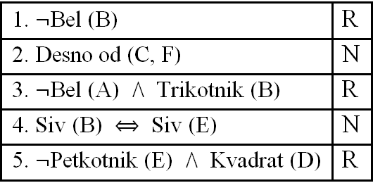C:\Users\mathema\AppData\Local\Microsoft\Windows\Temporary Internet Files\Content.Word\112-6-5q.wmf

C:\Users\mathema\AppData\Local\Microsoft\Windows\Temporary Internet Files\Content.Word\112-6-5a.wmf

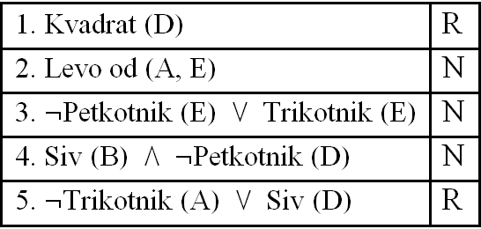C:\Users\mathema\AppData\Local\Microsoft\Windows\Temporary Internet Files\Content.Word\112-5-5q.wmf

C:\Users\mathema\AppData\Local\Microsoft\Windows\Temporary Internet Files\Content.Word\112-5-5a.wmf

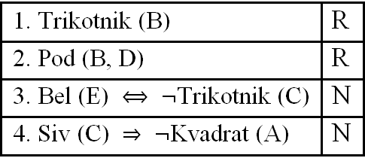C:\Users\mathema\AppData\Local\Microsoft\Windows\Temporary Internet Files\Content.Word\112-5-4q.wmf

C:\Users\mathema\AppData\Local\Microsoft\Windows\Temporary Internet Files\Content.Word\112-5-4a.wmf

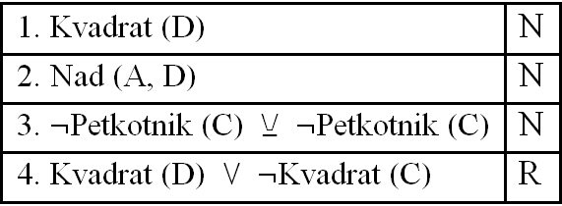C:\Users\mathema\AppData\Local\Microsoft\Windows\Temporary Internet Files\Content.Word\112-4-4q.wmf

C:\Users\mathema\AppData\Local\Microsoft\Windows\Temporary Internet Files\Content.Word\112-4-4a.wmf

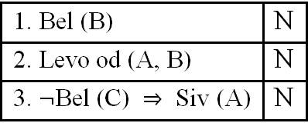C:\Users\mathema\AppData\Local\Microsoft\Windows\Temporary Internet Files\Content.Word\112-4-3q.wmf

C:\Users\mathema\AppData\Local\Microsoft\Windows\Temporary Internet Files\Content.Word\112-4-3a.wmf

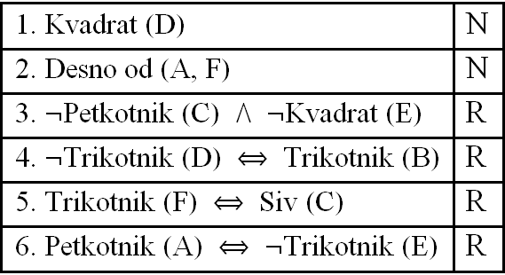C:\Users\mathema\AppData\Local\Microsoft\Windows\Temporary Internet Files\Content.Word\111-6-6q.wmf

C:\Users\mathema\AppData\Local\Microsoft\Windows\Temporary Internet Files\Content.Word\111-6-6a.wmf

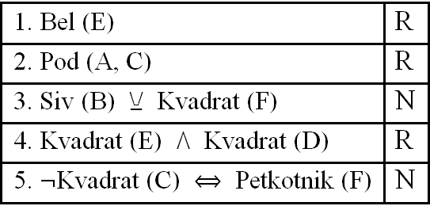C:\Users\mathema\AppData\Local\Microsoft\Windows\Temporary Internet Files\Content.Word\111-6-5q.wmfC:\Users\mathema\AppData\Local\Microsoft\Windows\Temporary Internet Files\Content.Word\111-6-5a.wmf

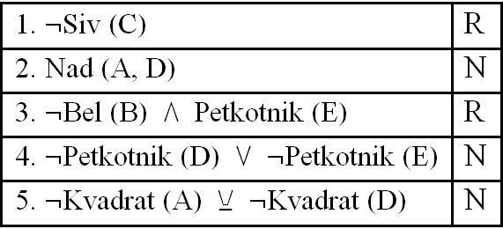C:\Users\mathema\AppData\Local\Microsoft\Windows\Temporary Internet Files\Content.Word\111-5-5q.wmf

C:\Users\mathema\AppData\Local\Microsoft\Windows\Temporary Internet Files\Content.Word\111-5-5a.wmf

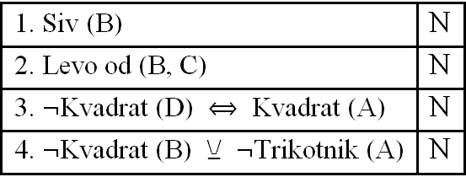C:\Users\mathema\AppData\Local\Microsoft\Windows\Temporary Internet Files\Content.Word\111-5-4q.wmf

C:\Users\mathema\AppData\Local\Microsoft\Windows\Temporary Internet Files\Content.Word\111-5-4a.wmf

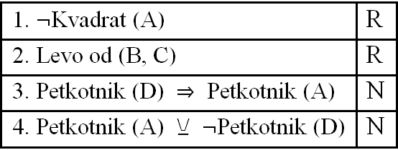C:\Users\mathema\AppData\Local\Microsoft\Windows\Temporary Internet Files\Content.Word\111-4-4q.wmf

C:\Users\mathema\AppData\Local\Microsoft\Windows\Temporary Internet Files\Content.Word\111-4-4a.wmf

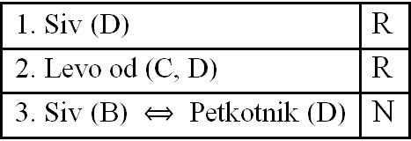C:\Users\mathema\AppData\Local\Microsoft\Windows\Temporary Internet Files\Content.Word\111-4-3q.wmf

C:\Users\mathema\AppData\Local\Microsoft\Windows\Temporary Internet Files\Content.Word\111-4-3a.wmf

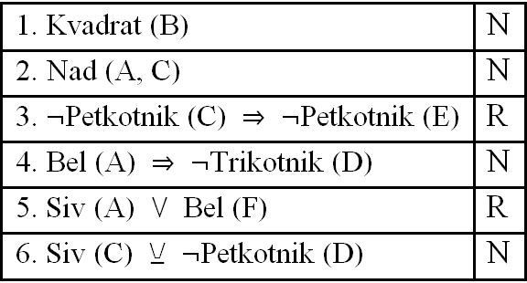C:\Users\mathema\AppData\Local\Microsoft\Windows\Temporary Internet Files\Content.Word\110-6-6q.wmf

C:\Users\mathema\AppData\Local\Microsoft\Windows\Temporary Internet Files\Content.Word\110-6-6a.wmf

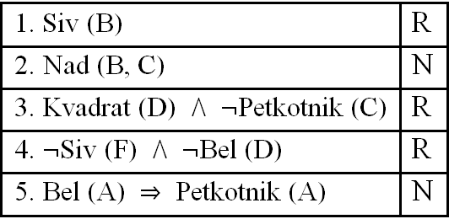C:\Users\mathema\AppData\Local\Microsoft\Windows\Temporary Internet Files\Content.Word\110-6-5q.wmf

C:\Users\mathema\AppData\Local\Microsoft\Windows\Temporary Internet Files\Content.Word\110-6-5a.wmf

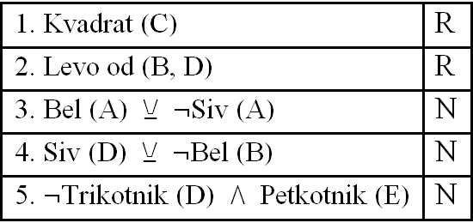C:\Users\mathema\AppData\Local\Microsoft\Windows\Temporary Internet Files\Content.Word\110-5-5q.wmf

C:\Users\mathema\AppData\Local\Microsoft\Windows\Temporary Internet Files\Content.Word\110-5-5a.wmf

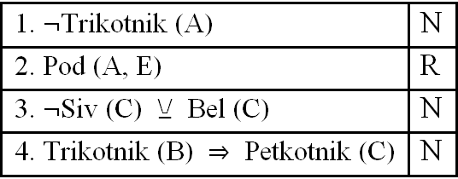C:\Users\mathema\AppData\Local\Microsoft\Windows\Temporary Internet Files\Content.Word\110-5-4q.wmf

C:\Users\mathema\AppData\Local\Microsoft\Windows\Temporary Internet Files\Content.Word\110-5-4a.wmf

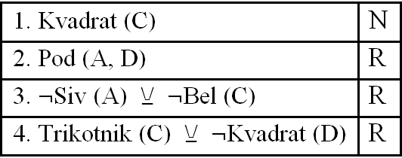C:\Users\mathema\AppData\Local\Microsoft\Windows\Temporary Internet Files\Content.Word\110-4-4q.wmf

C:\Users\mathema\AppData\Local\Microsoft\Windows\Temporary Internet Files\Content.Word\110-4-4a.wmf

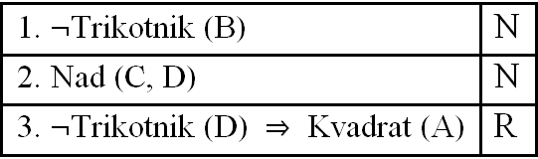C:\Users\mathema\AppData\Local\Microsoft\Windows\Temporary Internet Files\Content.Word\110-4-3q.wmf

C:\Users\mathema\AppData\Local\Microsoft\Windows\Temporary Internet Files\Content.Word\110-4-3a.wmf

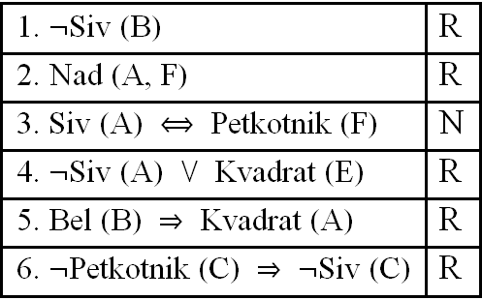C:\Users\mathema\AppData\Local\Microsoft\Windows\Temporary Internet Files\Content.Word\109-6-6q.wmf

C:\Users\mathema\AppData\Local\Microsoft\Windows\Temporary Internet Files\Content.Word\109-6-6a.wmf

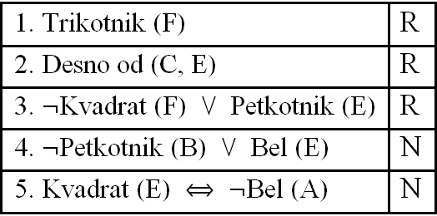C:\Users\mathema\AppData\Local\Microsoft\Windows\Temporary Internet Files\Content.Word\109-6-5q.wmf

C:\Users\mathema\AppData\Local\Microsoft\Windows\Temporary Internet Files\Content.Word\109-6-5a.wmf

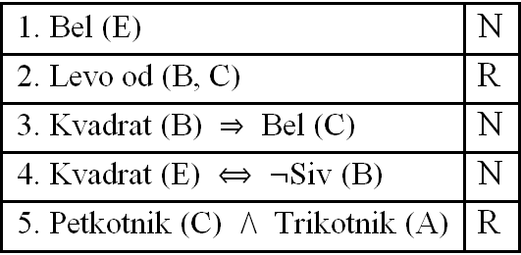C:\Users\mathema\AppData\Local\Microsoft\Windows\Temporary Internet Files\Content.Word\109-5-5q.wmf

C:\Users\mathema\AppData\Local\Microsoft\Windows\Temporary Internet Files\Content.Word\109-5-5a.wmf

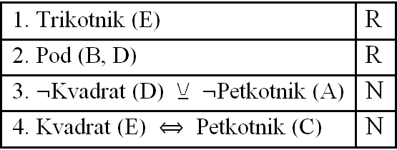C:\Users\mathema\AppData\Local\Microsoft\Windows\Temporary Internet Files\Content.Word\109-5-4q.wmf

C:\Users\mathema\AppData\Local\Microsoft\Windows\Temporary Internet Files\Content.Word\109-5-4a.wmf

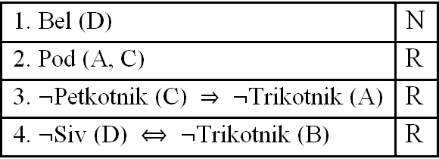C:\Users\mathema\AppData\Local\Microsoft\Windows\Temporary Internet Files\Content.Word\109-4-4q.wmf

C:\Users\mathema\AppData\Local\Microsoft\Windows\Temporary Internet Files\Content.Word\109-4-4a.wmf

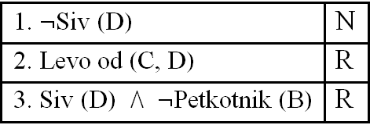C:\Users\mathema\AppData\Local\Microsoft\Windows\Temporary Internet Files\Content.Word\109-4-3q.wmfC:\Users\mathema\AppData\Local\Microsoft\Windows\Temporary Internet Files\Content.Word\109-4-3a.wmf

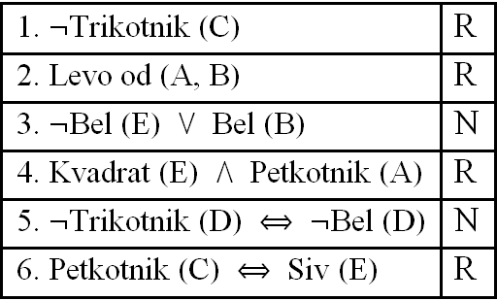C:\Users\mathema\AppData\Local\Microsoft\Windows\Temporary Internet Files\Content.Word\108-6-6q.wmf

C:\Users\mathema\AppData\Local\Microsoft\Windows\Temporary Internet Files\Content.Word\108-6-6a.wmf

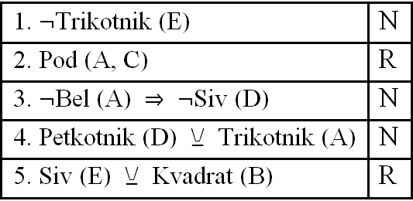C:\Users\mathema\AppData\Local\Microsoft\Windows\Temporary Internet Files\Content.Word\108-6-5q.wmf

C:\Users\mathema\AppData\Local\Microsoft\Windows\Temporary Internet Files\Content.Word\108-6-5a.wmf

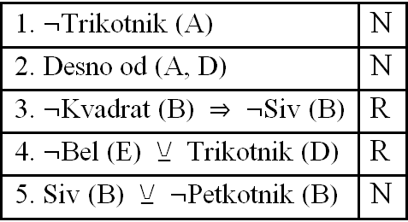C:\Users\mathema\AppData\Local\Microsoft\Windows\Temporary Internet Files\Content.Word\108-5-5q.wmf

C:\Users\mathema\AppData\Local\Microsoft\Windows\Temporary Internet Files\Content.Word\108-5-5a.wmf

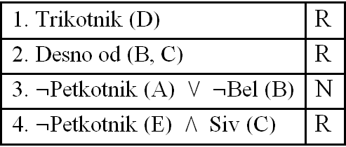C:\Users\mathema\AppData\Local\Microsoft\Windows\Temporary Internet Files\Content.Word\108-5-4q.wmf

C:\Users\mathema\AppData\Local\Microsoft\Windows\Temporary Internet Files\Content.Word\108-5-4a.wmf

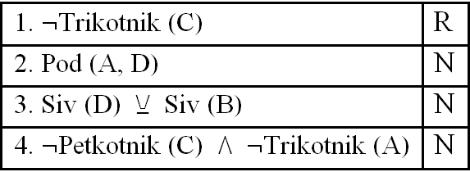C:\Users\mathema\AppData\Local\Microsoft\Windows\Temporary Internet Files\Content.Word\108-4-4q.wmf

C:\Users\mathema\AppData\Local\Microsoft\Windows\Temporary Internet Files\Content.Word\108-4-4a.wmf

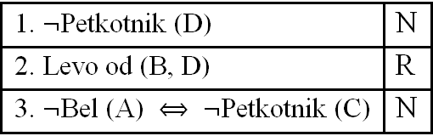C:\Users\mathema\AppData\Local\Microsoft\Windows\Temporary Internet Files\Content.Word\108-4-3q.wmf

C:\Users\mathema\AppData\Local\Microsoft\Windows\Temporary Internet Files\Content.Word\108-4-3a.wmf

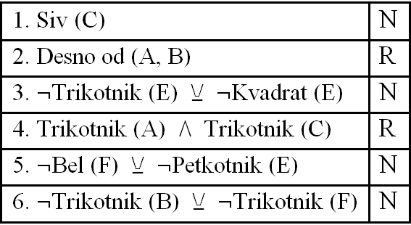C:\Users\mathema\AppData\Local\Microsoft\Windows\Temporary Internet Files\Content.Word\107-6-6q.wmf

C:\Users\mathema\AppData\Local\Microsoft\Windows\Temporary Internet Files\Content.Word\107-6-6a.wmf

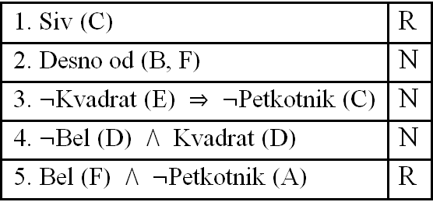C:\Users\mathema\AppData\Local\Microsoft\Windows\Temporary Internet Files\Content.Word\107-6-5q.wmf

C:\Users\mathema\AppData\Local\Microsoft\Windows\Temporary Internet Files\Content.Word\107-6-5a.wmf

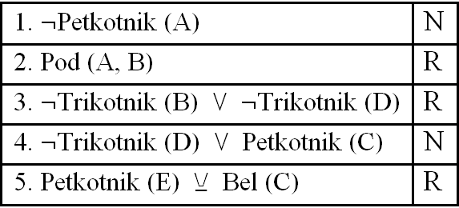C:\Users\mathema\AppData\Local\Microsoft\Windows\Temporary Internet Files\Content.Word\107-5-5q.wmf

C:\Users\mathema\AppData\Local\Microsoft\Windows\Temporary Internet Files\Content.Word\107-5-5a.wmf

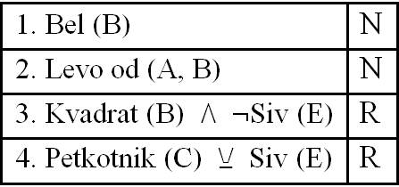C:\Users\mathema\AppData\Local\Microsoft\Windows\Temporary Internet Files\Content.Word\107-5-4q.wmf

C:\Users\mathema\AppData\Local\Microsoft\Windows\Temporary Internet Files\Content.Word\107-5-4a.wmf

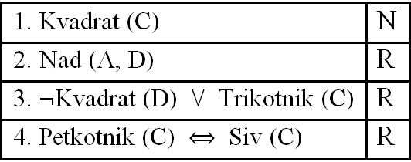C:\Users\mathema\AppData\Local\Microsoft\Windows\Temporary Internet Files\Content.Word\107-4-4q.wmf

C:\Users\mathema\AppData\Local\Microsoft\Windows\Temporary Internet Files\Content.Word\107-4-4a.wmf

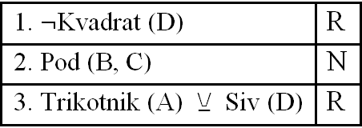C:\Users\mathema\AppData\Local\Microsoft\Windows\Temporary Internet Files\Content.Word\107-4-3q.wmf

C:\Users\mathema\AppData\Local\Microsoft\Windows\Temporary Internet Files\Content.Word\107-4-3a.wmf

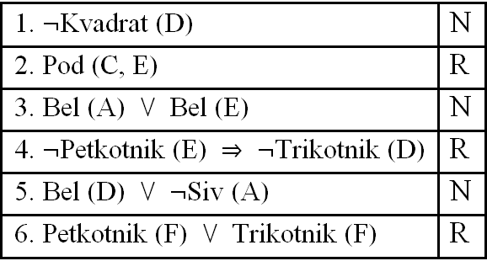C:\Users\mathema\AppData\Local\Microsoft\Windows\Temporary Internet Files\Content.Word\106-6-6q.wmf

C:\Users\mathema\AppData\Local\Microsoft\Windows\Temporary Internet Files\Content.Word\106-6-6a.wmf

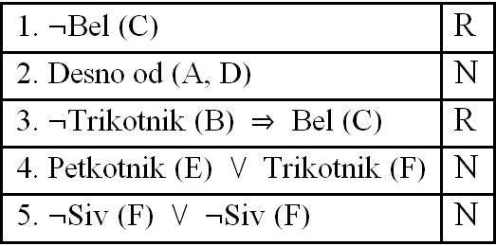C:\Users\mathema\AppData\Local\Microsoft\Windows\Temporary Internet Files\Content.Word\106-6-5q.wmf

C:\Users\mathema\AppData\Local\Microsoft\Windows\Temporary Internet Files\Content.Word\106-6-5a.wmf

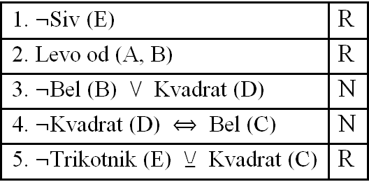C:\Users\mathema\AppData\Local\Microsoft\Windows\Temporary Internet Files\Content.Word\106-5-5q.wmf

C:\Users\mathema\AppData\Local\Microsoft\Windows\Temporary Internet Files\Content.Word\106-5-5a.wmf

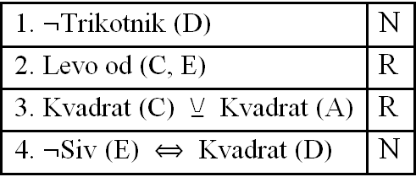C:\Users\mathema\AppData\Local\Microsoft\Windows\Temporary Internet Files\Content.Word\106-5-4q.wmf

C:\Users\mathema\AppData\Local\Microsoft\Windows\Temporary Internet Files\Content.Word\106-5-4a.wmf

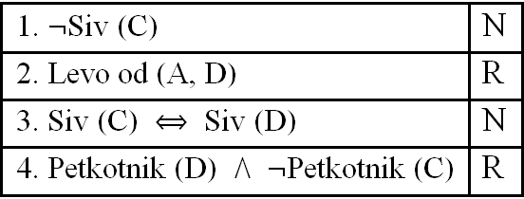C:\Users\mathema\AppData\Local\Microsoft\Windows\Temporary Internet Files\Content.Word\106-4-4q.wmf

C:\Users\mathema\AppData\Local\Microsoft\Windows\Temporary Internet Files\Content.Word\106-4-4a.wmf

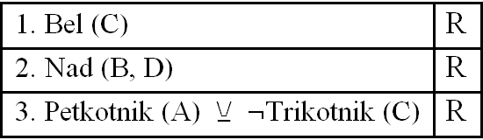C:\Users\mathema\AppData\Local\Microsoft\Windows\Temporary Internet Files\Content.Word\106-4-3q.wmf

C:\Users\mathema\AppData\Local\Microsoft\Windows\Temporary Internet Files\Content.Word\106-4-3a.wmf

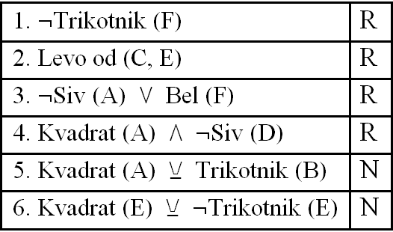C:\Users\mathema\AppData\Local\Microsoft\Windows\Temporary Internet Files\Content.Word\105-6-6q.wmf

C:\Users\mathema\AppData\Local\Microsoft\Windows\Temporary Internet Files\Content.Word\105-6-6a.wmf

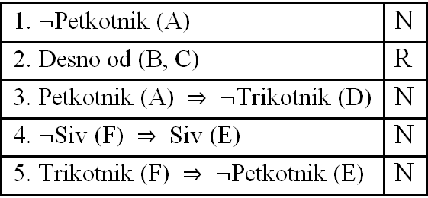C:\Users\mathema\AppData\Local\Microsoft\Windows\Temporary Internet Files\Content.Word\105-6-5q.wmf

C:\Users\mathema\AppData\Local\Microsoft\Windows\Temporary Internet Files\Content.Word\105-6-5a.wmf

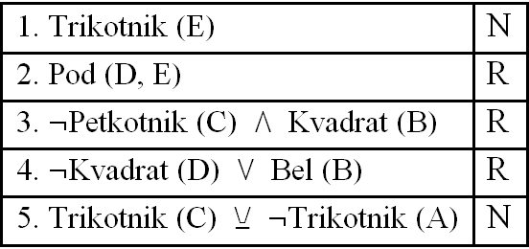C:\Users\mathema\AppData\Local\Microsoft\Windows\Temporary Internet Files\Content.Word\105-5-5q.wmf

C:\Users\mathema\AppData\Local\Microsoft\Windows\Temporary Internet Files\Content.Word\105-5-5a.wmf

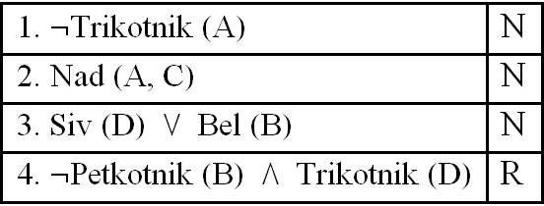C:\Users\mathema\AppData\Local\Microsoft\Windows\Temporary Internet Files\Content.Word\105-5-4q.wmf

C:\Users\mathema\AppData\Local\Microsoft\Windows\Temporary Internet Files\Content.Word\105-5-4a.wmf

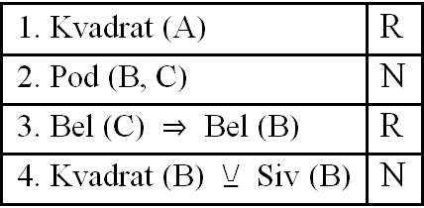C:\Users\mathema\AppData\Local\Microsoft\Windows\Temporary Internet Files\Content.Word\105-4-4q.wmf

C:\Users\mathema\AppData\Local\Microsoft\Windows\Temporary Internet Files\Content.Word\105-4-4a.wmf

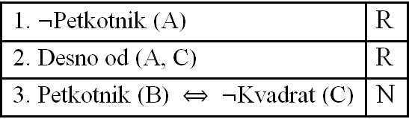C:\Users\mathema\AppData\Local\Microsoft\Windows\Temporary Internet Files\Content.Word\105-4-3q.wmf

C:\Users\mathema\AppData\Local\Microsoft\Windows\Temporary Internet Files\Content.Word\105-4-3a.wmf

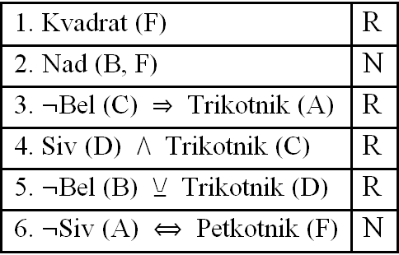C:\Users\mathema\AppData\Local\Microsoft\Windows\Temporary Internet Files\Content.Word\104-6-6q.wmf

C:\Users\mathema\AppData\Local\Microsoft\Windows\Temporary Internet Files\Content.Word\104-6-6a.wmf

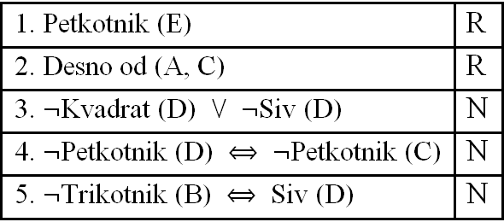C:\Users\mathema\AppData\Local\Microsoft\Windows\Temporary Internet Files\Content.Word\104-6-5q.wmf

C:\Users\mathema\AppData\Local\Microsoft\Windows\Temporary Internet Files\Content.Word\104-6-5a.wmf

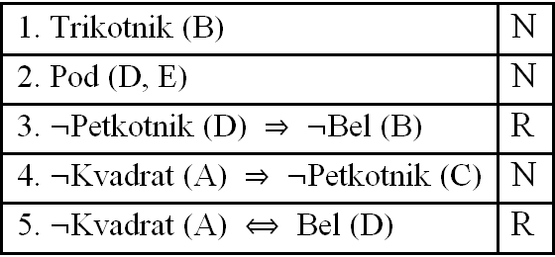C:\Users\mathema\AppData\Local\Microsoft\Windows\Temporary Internet Files\Content.Word\104-5-5q.wmf

C:\Users\mathema\AppData\Local\Microsoft\Windows\Temporary Internet Files\Content.Word\104-5-5a.wmf

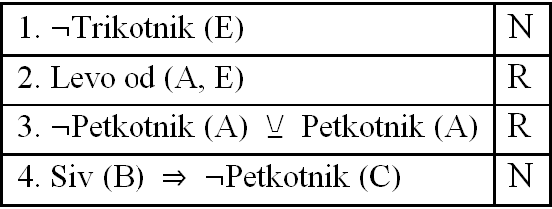C:\Users\mathema\AppData\Local\Microsoft\Windows\Temporary Internet Files\Content.Word\104-5-4q.wmf

C:\Users\mathema\AppData\Local\Microsoft\Windows\Temporary Internet Files\Content.Word\104-5-4a.wmf

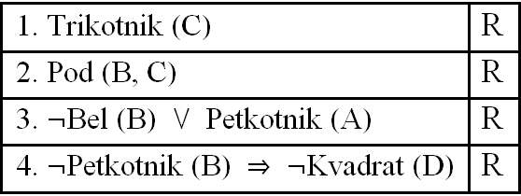C:\Users\mathema\AppData\Local\Microsoft\Windows\Temporary Internet Files\Content.Word\104-4-4q.wmf

C:\Users\mathema\AppData\Local\Microsoft\Windows\Temporary Internet Files\Content.Word\104-4-4a.wmf

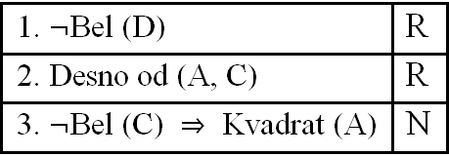C:\Users\mathema\AppData\Local\Microsoft\Windows\Temporary Internet Files\Content.Word\104-4-3q.wmf

C:\Users\mathema\AppData\Local\Microsoft\Windows\Temporary Internet Files\Content.Word\104-4-3a.wmf

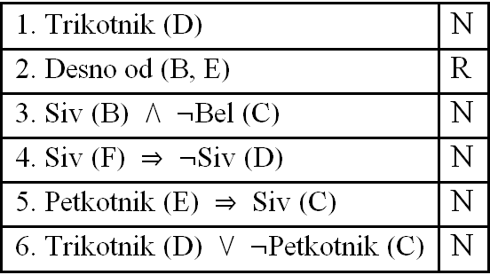C:\Users\mathema\AppData\Local\Microsoft\Windows\Temporary Internet Files\Content.Word\103-6-6q.wmf

C:\Users\mathema\AppData\Local\Microsoft\Windows\Temporary Internet Files\Content.Word\103-6-6a.wmf

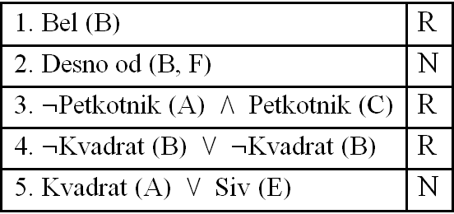C:\Users\mathema\AppData\Local\Microsoft\Windows\Temporary Internet Files\Content.Word\103-6-5q.wmf

C:\Users\mathema\AppData\Local\Microsoft\Windows\Temporary Internet Files\Content.Word\103-6-5a.wmf

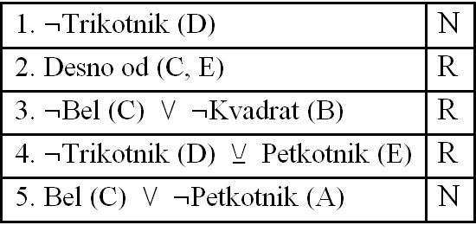C:\Users\mathema\AppData\Local\Microsoft\Windows\Temporary Internet Files\Content.Word\103-5-5q.wmf

C:\Users\mathema\AppData\Local\Microsoft\Windows\Temporary Internet Files\Content.Word\103-5-5a.wmf

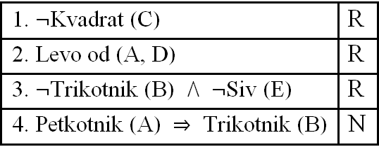C:\Users\mathema\AppData\Local\Microsoft\Windows\Temporary Internet Files\Content.Word\103-5-4q.wmf

C:\Users\mathema\AppData\Local\Microsoft\Windows\Temporary Internet Files\Content.Word\103-5-4a.wmf

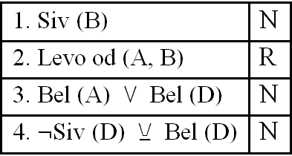C:\Users\mathema\AppData\Local\Microsoft\Windows\Temporary Internet Files\Content.Word\103-4-4q.wmf

C:\Users\mathema\AppData\Local\Microsoft\Windows\Temporary Internet Files\Content.Word\103-4-4a.wmf

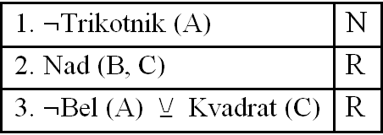C:\Users\mathema\AppData\Local\Microsoft\Windows\Temporary Internet Files\Content.Word\103-4-3q.wmf

C:\Users\mathema\AppData\Local\Microsoft\Windows\Temporary Internet Files\Content.Word\103-4-3a.wmf

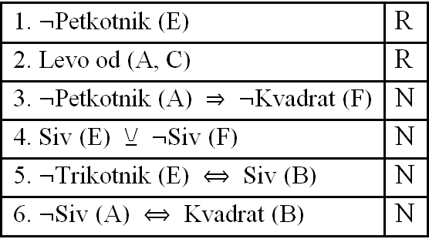C:\Users\mathema\AppData\Local\Microsoft\Windows\Temporary Internet Files\Content.Word\102-6-6q.wmf

C:\Users\mathema\AppData\Local\Microsoft\Windows\Temporary Internet Files\Content.Word\102-6-6a.wmf

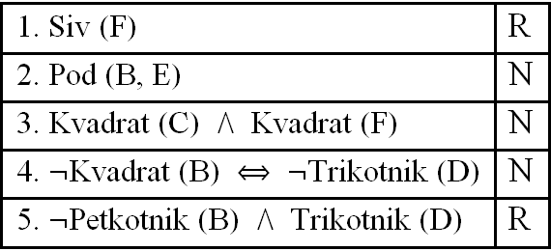C:\Users\mathema\AppData\Local\Microsoft\Windows\Temporary Internet Files\Content.Word\102-6-5q.wmf

C:\Users\mathema\AppData\Local\Microsoft\Windows\Temporary Internet Files\Content.Word\102-6-5a.wmf

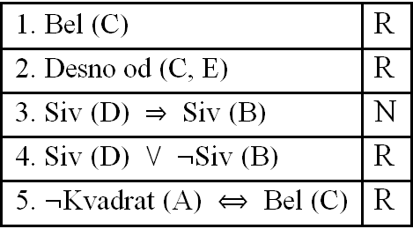C:\Users\mathema\AppData\Local\Microsoft\Windows\Temporary Internet Files\Content.Word\102-5-5q.wmf

C:\Users\mathema\AppData\Local\Microsoft\Windows\Temporary Internet Files\Content.Word\102-5-5a.wmf

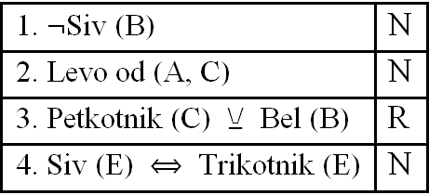C:\Users\mathema\AppData\Local\Microsoft\Windows\Temporary Internet Files\Content.Word\102-5-4q.wmf

C:\Users\mathema\AppData\Local\Microsoft\Windows\Temporary Internet Files\Content.Word\102-5-4a.wmf

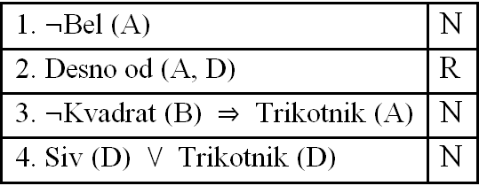C:\Users\mathema\AppData\Local\Microsoft\Windows\Temporary Internet Files\Content.Word\102-4-4q.wmf

C:\Users\mathema\AppData\Local\Microsoft\Windows\Temporary Internet Files\Content.Word\102-4-4a.wmf

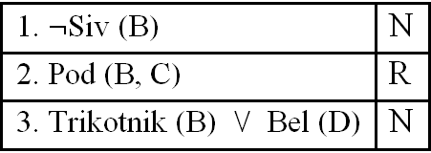C:\Users\mathema\AppData\Local\Microsoft\Windows\Temporary Internet Files\Content.Word\102-4-3q.wmf

C:\Users\mathema\AppData\Local\Microsoft\Windows\Temporary Internet Files\Content.Word\102-4-3a.wmf